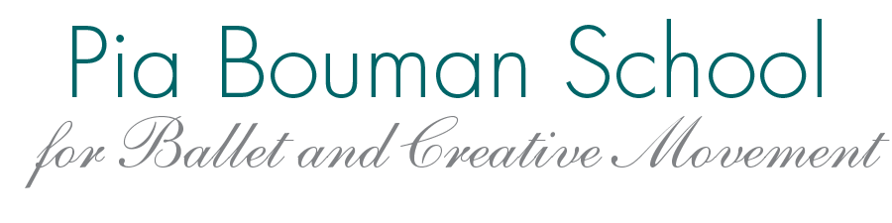

REGISTRATION FORM 2019-2020
36 weeks of classes beginning Monday, Sept 9, 2019, ending Sunday, June 21, 2020

Please read our fee policies online or at school, carefully before submitting registration. Registration accepted only if all 2018-19 fees are paid in full.
PLEASE SIGN BACK OF FORM
STUDENT INFORMATION
Name |  |  |  | M / F | New / Returning |  | DOB
 | Last |  | First
Address |  |  |  |  |  | Postal Code
Medical Alert

PARENT/GUARDIAN INFORMATION

Name |  |  |  |  |  | Phone
 | Last | First
Address |  |  | Postal Code |  |  |  | Email
Name |  |  |  |  |  | Phone
 | Last | First
Address |  |  | Postal Code |  |  |  | Email

EMERGENCY CONTACT if other than parent(s)
Name |  |  |  | Phone
 | Last | First | Relationship
** Contact information will be used for school purposes only and will not be shared. **

CLASS NAME/level | DAY & TIME | DURATION | PRICE
 | total hours and total fees: |  | $
Full Payment Discount (fees paid in full and received by Sept. 9) 5% of total CLASS fees  EXCLUDES Sweet Deal, Admin fee, Skirt rental, YMI fees, Nutcracker, RAD. |  |  | -
Family Discount (2 or more children) 3% of total CLASS fees  EXCLUDES Sweet Deal, Admin fee, Skirt rental, YMI fees, Nutcracker, RAD. |  |  | -
Administration Fee per student (NON refundable) $50.00 |  |  | + 50.00
Let’s Dance Festival Fee 1 class $25.00, 2 or more $50.00
Skirt Rental (NON refundable) $25.00 Primary, $30.00–Grade 1-8 or Technique 1
SWEET DEAL $450.00 (1 hr class) $650.00 (1.5 hr class) IF taken with one or more ballet class. |  |  | +
(any other fees must be paid as they arise: Nutcracker, RAD exams, workshops..)
 |  | TOTAL

We DO NOT accept CASH; fees must be made in full, in 2 or in 4 payments.
A student will be fully registered when you have signed this form and a payment or an agreement has been made.
** Bursaries available, please ask for required forms and provide proof of income as necessary. Appointment with the Artistic Director must be made to approve all bursaries **

BURSARY AMOUNT APPROVED _______________________ APPLIED - DATE______________________________

OFFICE USE | DATE | $ AMOUNT | Method of Payment | Batch | Processed by | Date Processed
IN FULL  5% discount | by Sept. 9
2 Payments | by Sept 9  ½ fees
Feb 15
½ class fees
4 Payments | by Sept 9  ¼ fees
Nov 15
¼ fees
Feb 15
¼ fees
April 15
¼ fees
Term 1 / September 9 – February 16 Term 2 / February 17 – June 21

Payments accepted: Cheque or PD cheques / EFT / Visa / MC NSF cheques will be charged $60.00
Credit Card Authorization I authorize Pia Bouman School for Ballet to debit the above payments from my Visa/MasterCard below

Card # ___________________________________________________ Exp ____________ Signature__________________________

Name ___________________________________________________ Phone ______________________________________________
I understand and agree that by signing below, this constitutes a legally binding agreement to pay the total amount indicated above in full no later than April 15, 2020.

Participation Release
I hereby certify that my child is in good physical condition and that they are able to participate fully in this program. All current medical conditions are outlined in this form. I understand the inherent risk involved in the physical activity of dancing and I release Pia Bouman School for Ballet and Creative Movement and its teachers and staff from liability in case of accident or injury. I understand classes will be conducted in the safest manner possible by fully trained, professional instructors.

Photo Release
I hereby give Pia Bouman School for Ballet and Creative Movement the right and permission to publish, without charge, photographs or videos taken of my child participating in school classes, performances and events. These photographs/videos may be used in publications, including electronic publications or in audiovisual presentations, literature and advertising or in similar ways. This release includes Nutcracker 2019, March Break Camp 2020, Let’s Dance Festival 2020 and Summer Camp 2020, social media and other events as applicable.

Fee Withdrawal and Refund Policy
I have read the entire school fee policy published on our website and available at the school.
I have read and agree to the above releases/policies, this form must be signed.

Parent/Guardian Signature _________________________________ Name______________________________ Date____________________

